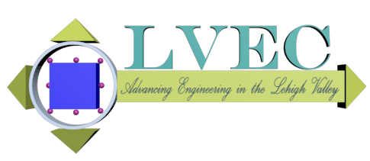
Lehigh Valley Engineering Council
41st Annual Engineer’s Week Banquet

Registration Form
Date: April 26, 2022

Time: 6:00 pm Cocktail Hour (2 drinks included per person)

7:00 pm – 9:30 Dinner and Program
Location: The Wood Dining Room at the Iacocca Conference Center
111 Research Drive, Bethlehem, PA 18015
Registration: http://lvengineeringcouncil.org/EngWeekBanquet
Deadline is April 8 for early registration; April 20 for late registration

Cost: (per Person) $55 if paid by credit card online (preferred) or by check received by April 8
$25 for students, if paid by credit card online (preferred) or by check received by April 8
$70 if paid between April 9th and 20th
+ $30 (optional) to sponsor a student*
For more information, please see http://lvengineeringcouncil.org/EngWeekBanquet.
If you have questions, please contact Mike Fries, LVEC Chair, at mcfries@ptd.net.

Please check one:
This is an individual registration – Please complete the information below; then send this form and a check to the address below.
This is a sponsorship – Please complete the information below and on the following page; then send this form and a check to the address below.
Name:

Organization or Company:

Email Address:

Total Amount Enclosed:
Please make check payable to Lehigh Valley Engineering Council
Send check and form to: LVEC
c/o Ricki Wagner
7733 Hill Street
Fogelsville, PA 18051
* By choosing to “sponsor a student,” you are covering the $30 difference between the cost of a Student Registration and LVEC’s actual cost to run this event.
ADDITIONAL SPONSOR REGISTRATION INFORMATION

 |  | Amount Provided
PLATINUM Sponsor (up to 12 seats) | $1000
GOLD Sponsor (up to 8 seats) | $650
SILVER Sponsor (up to 4 seats) | $350
BRONZE Sponsor (1 seat) | $100
Additional Attendees | _____ x $55 =
Additional Student Attendees | _____ x $25 =
Sponsor a Student* | _____ x $30 =
 | TOTAL =
- If a PLATINUM or GOLD sponsor, will you be setting up a display during the social hour? ⇨ Yes ⇨ No
- Please have each attendee register online as a sponsored guest (http://lvengineeringcouncil.org/EngWeekBanquet)

Please write each sponsored attendee’s name below for verification of online registrations

Attendee Name | Sponsor or member’s organization | STUDENT?  (y OR n)
* By choosing to “sponsor a student,” you are covering the $30 difference between the cost of a Student Registration and LVEC’s actual cost to run this event.

